1. Data Exploration

*Removed all ‘?’ values and NULL values if there are any in the given ‘Cleveland’ dataset.*

1. Data Analysis

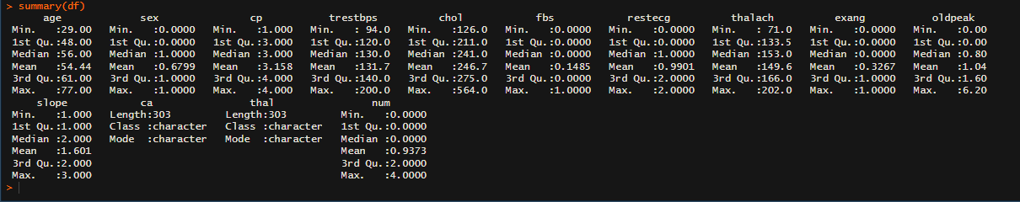

1. Data Modeling